NOVA 16 Firestorm Armada
Grand Tournament

Tournament Format
Maximum Fleet Value: 800 point Patrol Fleet using the Composition Table
When: Saturday of the 2016 NOVA
Where: Hyatt Regency in Alexandria, VA
Start Time: TBD
Cost: TBD
Rules: All rules from the Rulebook, plus all current FAQs/Errata, Fleet Manuals, and System Wars.
Optional Rules, such as Voluntary Decompression, will not be used for this Tournament.
The Rulebook Version and Fleet Manuals will be “locked” as of August 1st.
Rulebook FAQ/Clarifications and TACs will be locked September 1st.

Tournament Scoring
Normal rules for Battle Log will be used during each Mission. When the game reaches its natural conclusion, or is called for time, players will add any Scenario Points, then compare their Battle Log to determine their Tournament Points (using the Margin of Victory Table from page 84 in the Rulebook)
Difference | Leading Player Tournament Points | Trailing Player’s Tournament Points
0 to 4 | Draw; 5 points | Draw; 5 points
5 to 9 | Marginal Success; 7 points | Marginal Loss; 4 points
10 to 14 | Major Triumph; 9 points | Major Defeat; 2 points
15+ | Landslide Victory; 11 points | Complete Rout; 0 points
If a player is forced to Emergency Shunt Out (page 83), then this will be considered a Landslide Victory for their opponent (11 points) and a Complete Rout for them (0 points), regardless of final Battle Log.
Missions: There will be 4 Missions and players will have a 2 hour time limit to complete each Mission.

What you will need
Fleet List: Fleet lists must be submitted electronically by August 1st. Players must have a copy of their Fleet List with the Nova Stamp of Approval available for review by your opponent and judges at any time during the GT. Star Admiral Tier 1 and SRS Token types must be specified.
Models: Fleets will be comprised of the current factions listed in the Fleet Manuals. Fleets will consist of Firestorm Armada Models currently available from Spartan Games. If a Model is not currently made by Spartan, then a suitable Proxy Model may be used. Proxy Models must be similar in size to ships of the appropriate size Class. They must also use the same-sized base as Models of the same Class currently available from Spartan.
Flight Stands: All players will use the supplied Flight Stand which came with their Model and the Flight Peg unmodified, with the following exceptions:
- Hawk Widgets: These may be applied to either end of the Flight Peg
- Corsec Omni-stand Flight Pegs: Only 2” pegs will be permitted
- Version 1 Models: These came with the normal flight stand, but if a Player wishes to instead use a Large Flight Stand for Large ships, they will be allowed to do so.
- Uneven Models: The Dindrenzi Praetorian (and other models) require modification to sit on the Flight Stand. One Flight Peg must be unmodified.
Rule Books: All players must have a copy of the August 1st Rulebook, Fleet Guide, and FAQs available at all times during the GT. This can be a digital copy but must be available for judges to view if asked. If a battery has died, you will have 10 minutes to recharge and display the digital copy.
Gaming Supplies: Players are expected to bring all of the required Gaming Supplies for a game of Firestorm Armada:
- Firestorm Armada Turning Template
- 48”+ Tape Measure
- Enough Dice for their Fleet (suggest 36)
- Latest version of Tactical Ability Cards (TACs)
- Firestorm Armada Markers (bring enough for your Fleet, including Hidden Set-up)

Tournament Rounds and Rotation
Round 1, all Participants will be randomly matched with an opponent, and assigned a Table. Each subsequent Round, players will rotate through each of the remaining three Table/Mission pairs, playing on each Table Layout, and playing a different opponent each game. In addition, if participants are from the same demographic area, they may request to not play each other, and the Tournament Organizers will attempt to prevent these pairing when setting the initial pairings and rotation.
If there is an odd number of participants at any time, one of the Tournament Organizers will play the Odd-Man Out. Tournament Scoring will not be adjusted; there is no ‘bye’. In addition, Players will only play a Tournament Organizer once, if necessary, and will not play someone they have played before at the Tournament. Fleet Lists for the Tournament Organizers will also have a Nova Stamp of Approval and be available August 2nd.
While playing the Odd-Man Out, the Tournament Organizer will not perform any other Tournament Organizer duties.

Missions and Table Layouts
Each Round will be held on a 4’x6’ Table, with Terrain already placed. The Terrain Layout will determine which Mission the players will play for each round, as well as a small plaque stating the Mission being used at every Table. Players will not be allowed to move the Terrain Templates, but adjusting the decorative 3D Terrain Models is allowed. If there are any questions as to which Mission to play on any given Table, or the Terrain Layout, please ask a Tournament Organizer.

Tournament Prizes
Major prizes will be awarded for the following, by this ranking:
- Tournament Champion, as determined by Tournament Points
- 2nd Place Tournament, as determined by Tournament Points
- 3rd Place Tournament, as determined by Tournament Points
- Highest Tournament Points from Rounds 3&4
- 2nd Highest Tournament Points from Rounds 3&4
- 3rd Highest Tournament Points from Rounds 3&4
- Best Painted, as determined by a NOVA Painting Judge
- Player-voted Best Sport
Player-voting will be conducted after the final Mission; a spot on your score sheet will be available to vote for Best Sportsman.
In the event of a tie Tournament Point, total Battlelog will be used as a tie-breaker. If there is still a tie, and they have not player each other in the Tournament, then a best of three dice-off will be used.
There will be additional prizes awarded for the remaining players based on placement in the Tournament.

Mission 1 – Intensifying Engagement

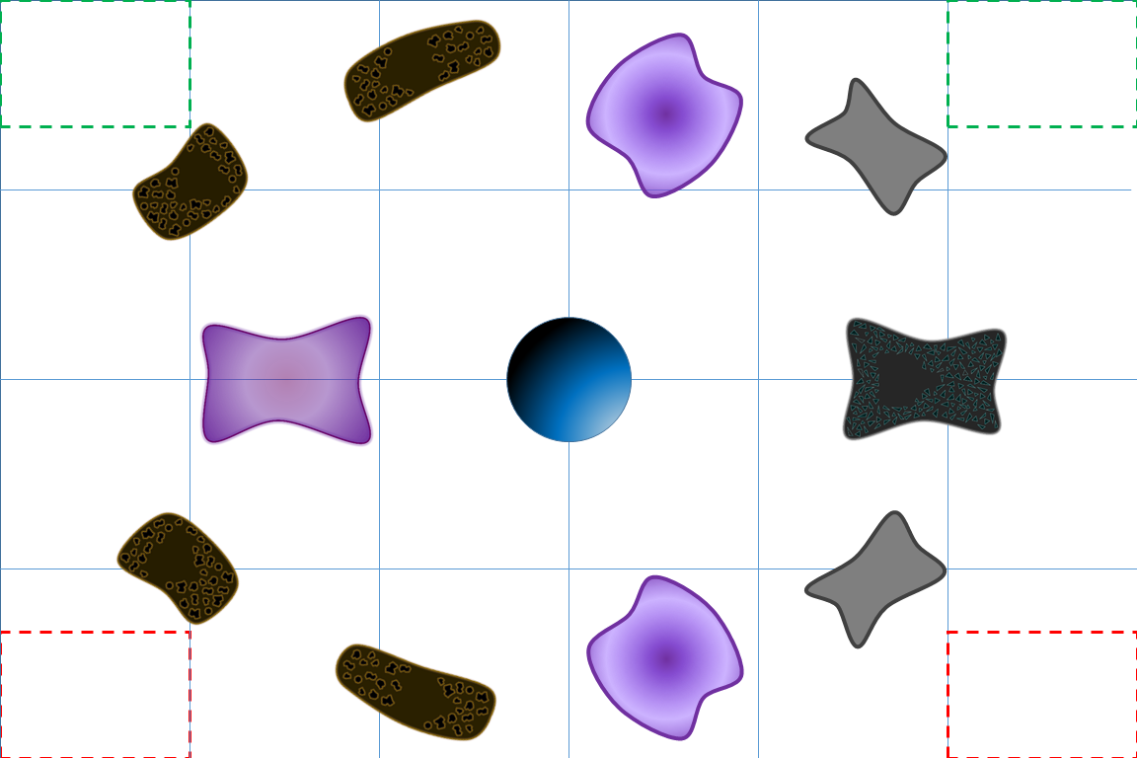
TERRAIN: This Scenario uses the above Table Design
DEPLOYMENT: Players will deploy all Tier 3 forces on the board. Deployment Zones will be both opposing corners in an 8”x12” box along the Long Edge. Tier 1 and Tier 2 must be held in Reserve. Tier 2 may automatically Flank Entry on Turn 2 into your Deployment Zones, and Tier 1 may automatically Flank Entry on Turn 3 into your Deployment Zone.
You may also attempt to bring in ships from Reserves starting Turn 2 using the standard Reserve Rules; you may only Flank Entry onto a Short Edge or your Long Edge; Shunt Entry is not allowed.
Primary Objective (+4 Battle Log): Have more Tier 3 Models on the table at the end of the game.
Secondary Objective (+2 Battle Log): Secure more Table Quarters than your opponent, by having more Models in each Quarter than your opponent.
VICTORY CONDITIONS: Compare Final Battle Logs at Round’s end to determine the Margin of Victory
GAME LENGTH: During the End Phase of Turn 6, the Commander first in the order of Initiative should roll a D6. On a result of 1, 2 or 3 the game ends. On a roll of 4, 5 or 6 another Turn is played. Roll again during the End Phase of Turn 7, but subtract 1 from the result. If an 8th Turn is played, roll again but subtract 2 from the result. The game automatically ends during the End Phase of Turn 9.

Mission 2 – Secure the Trade Lane
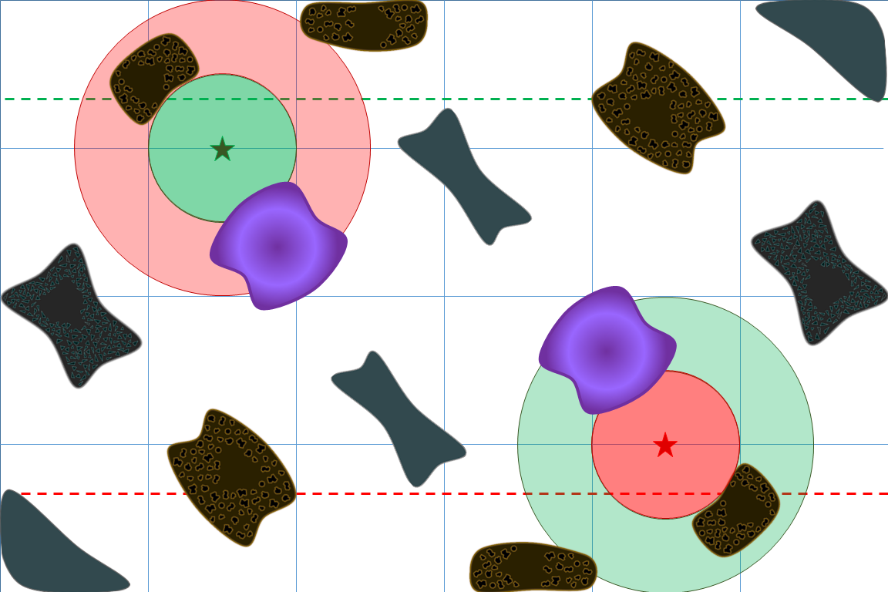
TERRAIN Each Player will have a Waypoint placed 18” from their right Board Edge, and 12” from their Long Board Edge.
DEPLOYMENT This Scenario follows the normal rules for choosing your Deployment Zone and placing your Forces, using 8” from the Long Table Edge.
Primary Objective (+2 Battle Log): Secure a Waypoint Relay at the end of the game (each grants +2) by having one or more Squadrons entirely within 6" of a Waypoint Relay, and there are no enemy Models within 12" of the Relay.
Secondary Objective (+1 Battle Log): During the End Phase of each Turn, score +1 Battlelog for securing a Waypoint Relay as described above.
VICTORY CONDITIONS Compare Battle Logs at the end of the game to determine the Margin of Victory
GAME LENGTH During the End Phase of Turn 6, the Commander first in the order of Initiative should roll a D6. On a result of 1, 2 or 3 the game ends. On a roll of 4, 5 or 6 another Turn is played. Roll again during the End Phase of Turn 7, but subtract 1 from the result. If an 8th Turn is played, roll again but subtract 2 from the result. The game automatically ends during the End Phase of Turn 9.

Mission 3 – System Conquest
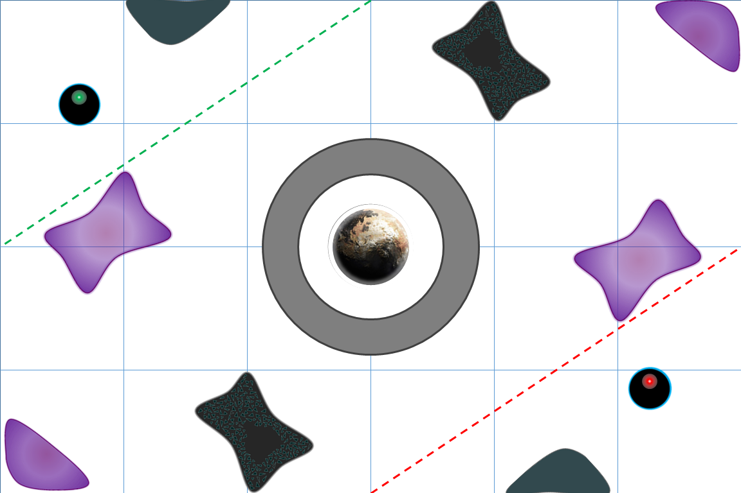
TERRAIN This Scenario uses the above Table Design.
DEPLOYMENT Each Player will use the Corner Deployment zone containing a Ghost Station.
Primary Objective (+4 Battle Log): Secure the center planet’s orbit. You must have more Capitol Ships (typically Tier 1&2) within 4” of the planet then your opponent at the end of the game.
Secondary Objective (+2 Battle Log): Capture your opponent’s Ghost Station (destruction is 0 points).
VICTORY CONDITIONS Compare Battle Logs at the end of the game to determine the Margin of Victory
GAME LENGTH During the End Phase of Turn 6, the Commander first in the order of Initiative should roll a D6. On a result of 1, 2 or 3 the game ends. On a roll of 4, 5 or 6 another Turn is played. Roll again during the End Phase of Turn 7, but subtract 1 from the result. If an 8th Turn is played, roll again but subtract 2 from the result. The game automatically ends during the End Phase of Turn 9.
Mission 4 – Capture Ancient Beacons
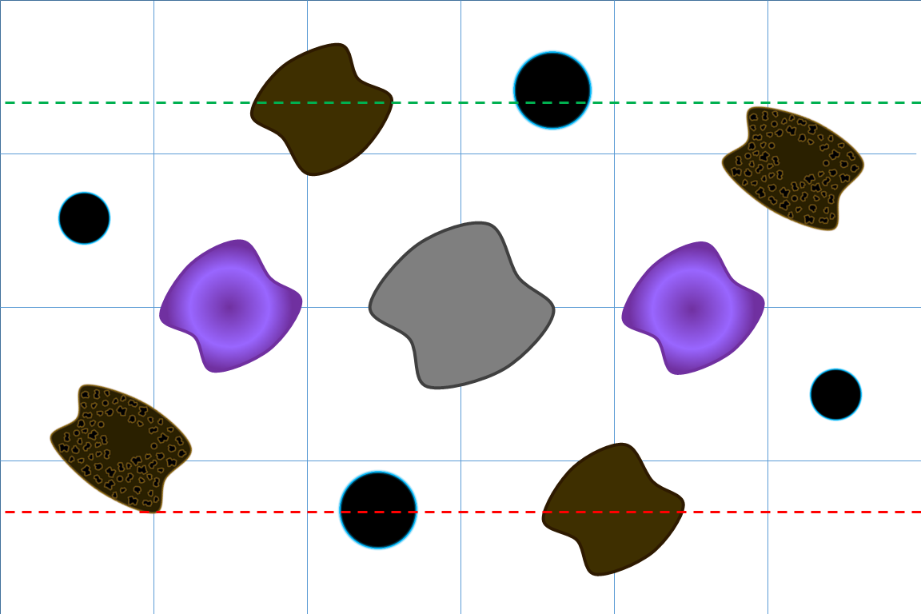
TERRAIN A Gravity Beacon is placed in the center of each large Gas Cloud and the Central Debris Field
DEPLOYMENT This Scenario follows the normal rules for choosing your Deployment Zone and placing your Forces. Each player will have 12” from each Short Table Edge.
SCENARIO RULES When Secured, Gravity Towers can be used to push/pull. Gravity towers can link fire if player Secures two or more towers; then they may be used to cause damage. Gravity Towers cannot be used on each other to push/pull. Gravity Towers cannot be damaged or destroyed, only Captured through a Boarding Assault. The Gravity Towers are non-Capital ships, and have the following profile:
DR | CR | MV | TL | HP | CP
- | - | 0” | 0” | - | 0
Sh | PD | AP | Mn | WC | Pts
- | 5 | 5 | - | - | -
Gravity Weapon |  | 6” | 12” | 24” | 48”
Turret (Any) |  | 12 | 10 | 6 | 4
MARs |  | Unmanned, No FSD

There are 2 ways to Secure the Gravity Towers. First is to have a Model within 4” of the tower with no enemy Models within 4” of the tower. If both players have ships within 4” of a Tower then it is contested and no player may Secure. The second way is to Assault and Capture the tower. If you Capture the tower, then you Secure it regardless of the enemy being within 4” of the tower.
Primary Objective (+4 Battle Log): Secure two or more Gravity Towers at the end of the game.
Secondary Objective (+2 Battle Log): Secure your Opponent’s Deployment Zone, by having more Models in it than your opponent.
VICTORY CONDITIONS Compare Battle Logs at the end of the game to determine the Margin of Victory
GAME LENGTH During the End Phase of Turn 6, the Commander first in the order of Initiative should roll a D6. On a result of 1, 2 or 3 the game ends. On a roll of 4, 5 or 6 another Turn is played. Roll again during the End Phase of Turn 7, but subtract 1 from the result. If an 8th Turn is played, roll again but subtract 2 from the result. The game automatically ends during the End Phase of Turn 9.

Thursday: Build and Play
Thursday Afternoon Event: 500 MFV, 3 Rounds, using modified Fleet Building rules; Winners Bracket and Losers Swiss Pairings. (Surprise: If you were in the Build and Play, you don’t have these restrictions)
Scenarios 1, 2, & 4
Restrictions: No Battleships, No Battlestations, No Admirals (Still 2 Successes)
Saturday: 800 points, 4 rounds, 2.5 hours max, 12 hours max
Sunday: 1200 points, 2 rounds: 4 hours each. Zenian vs. Kurak, with Mercenaries/Rogues selected by Team Captains to make the Teams even. Team Captains will be selected based on highest Total Battlelog from Friday and Saturday; Rogues will be designated by the TOs. For each Round, Teams will split themselves into “Attackers” and “Defenders”. After a coin flip to determine Initiative, the winning team Captain will assign an “Attacker” to an opposing team’s “Defender”. The “Defender” will then select a table to play upon. Pairings will then alternate between teams until everyone has an opponent.
If possible, Mercenaries will switch sides between rounds.
Round 1 – Capture the Station
Round 2 - Ambush

Map Legend
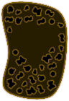Asteroid Field
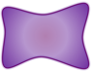 Gas Cloud
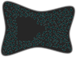 Debris Field
Planetoid
Ghost Station
Deployment Zone

