NOVA 2016 Firestorm Armada
Doubles Tournament

Tournament Format
Maximum Fleet Value: 500 point Patrol Fleet
When: Saturday of the 2016 NOVA
Where: Hyatt Regency in Alexandria, VA
Time: 9am-4pm
Cost: TBD
Rules: All the standard rules from version 2.0 Rulebook, plus all current FAQs/Errata. Optional Rules will be used for this Tournament.
Fleets: Fleets will be comprised of the current factions listed in the Fleet Manuals. Fleets will consist of ship Models currently available from Spartan Games. If a Model is not currently made by Spartan, then a suitable Proxy Model may be used. Proxy Models must be similar in size for ships of the appropriate Class. They must also use the same sized base as Models currently available from Spartan.
Scoring: Scoring will be done using the Victory Points (VP) listed on pg. 84 of the Rulebook.
Players are awarded Victory Points equal to:
• Double the Points Cost of any models which have been Captured and taken into Fold Space.
• The Full Points Cost for any enemy models that have been Destroyed or moved off the Game Board.
• Half the Points Cost of any enemy models which make a Fold Space Escape.
• Half the Points Cost of any Lead Tier 1 models which are reduced to half their initial Hull Points or fewer, but have not been removed from the Game Board.
• Any Scenario Rules or Victory Conditions which cause a player to increase their Battle Log, instead award 50 Victory Points per point awarded.
• Once both players have calculated their Victory Points at the end of the game, they should compare their totals to determine the outcome of the battle:
Difference Margin
Less than 10% Draw
10 - 30% Leading Team scores a Marginal Success
30 - 50% Leading Team scores a Major Triumph
50% or more Leading Team scores a Landslide Victory
Missions: There will be 3 Missions and players will have a 1.5 hour time limit to complete each Mission. Players must make every attempt to complete to Turn 4. If Turn 4 is not completed in 1.5 hours, then the Tournament Organizers will either 1) allow the players to finish the Turn, or 2) make a judgement on the likely outcome for the rest of the game based on current positioning. The option chosen will be based on time constraints and conditions within NOVA. Tournament Points will be awarded accordingly.
Fleet List: Fleet lists must be submitted electronically by August 1st. Players must have a copy of their Fleet List with the Nova Stamp of Approval available for review by your opponent and judges at any time during the GT.
Rulebook: All players must have a copy of the current Rulebook and FAQs available at all time during the GT. This can be a Digital copy but must be available for judges to view if asked. If your battery has died, you will have 10 minutes to recharge and demonstrate you have the digital copy.

Tournament Prizes
Major prizes will be awarded for the following, by this ranking:
- Tournament Champions, as determined by Victory Points
- 2nd Place Tournament, as determined by Victory Points
- 3rd Place Tournament, as determined by Victory Points
- Best Sportsman by Player Vote
- Best Pairing by Player Vote
Player-voting will be conducted after each mission. A spot on your score sheet will be available to vote for Best Sportsman, Etc.
There will be additional prizes awarded for the remaining players based on placement in the Tournament.

Tournament Rounds and Rotation
Round 1, all Participants will be paired randomly and matched with another paired opponent. You will be assigned a Table. Each subsequent Round, players will rotate through each of the three Table/Mission pairs, playing on Table Layout, and playing a different opponent pairing each game. In addition, if participants are from the same demographic area, they may request to not play each other, and the Tournament Organizers will attempt to prevent these pairing when setting the initial pairings and rotation.
If there is an odd number of participants at any time, one of the Tournament Organizers will play the Odd-Man Out. Tournament Scoring will not be adjusted; there is no ‘bye’. In addition, Tournament Organizers will not play someone they have played before, either at the Tournament or otherwise. Fleet list for the Tournament organizers will also have a Nova Stamp of Approval and be available any time for the Players to view.
While playing the Odd-Man Out, the Tournament Organizer will not perform any other Tournament Organizer duties.
Also Tournament Organizers may be paired with participants from the Learn to Play event and will play competitively in the event.

Missions and Table Layouts
Each Round will be held on a 4’x6’ Table, with Terrain already placed. The Terrain Layout will determine which Mission the players will play for each round, as well as a small plaque stating the Mission being used at every Table. Players will not be allowed to move the Terrain Templates, but adjusting the decorative 3D Terrain Models is allowed. If there are any questions as to which Mission to play on any given Table, please ask a Tournament Organizer.
TAC Cards: There are several TAC cards that allow you to lower Battlelog in order to receive an effect. The cost of 1 Battle Log point is 50 Victory Points. Also, you will not be able to buy back TAC Cards.

1 - BORDER CLASH
OVERVIEW This is the most basic form of battle, with both sides simply aiming to inflict heavy casualties on the other, without sustaining too many losses.
TERRAIN This Scenario has no special Terrain requirements. Simply set up the Game Board using one of the methods described on Page 35.
DEPLOYMENT This Scenario follows the normal rules for choosing your Deployment Zone and placing your Forces. The shapes of the Deployment Zones are shown on the Scenario Map.
SCENARIO RULES Each Squad you destroy without the help of your partner is worth:
Tier 3: 25 extra VP
Tier 2: 50 extra VP
Tier 1: 100 extra VP
VICTORY CONDITIONS This Scenario has no additional Victory Conditions. Simply compare Battle Logs at the end of the game to determine the Margin of Victory (see Page 82).
GAME LENGTH During the End Phase of Turn 6, the Commander first in the order of Initiative should roll a D6. On a result of 1, 2 or 3 the game ends. On a roll of 4, 5 or 6 another Turn is played. Roll again during the End Phase of Turn 7, but subtract 1 from the result. If an 8th Turn is played, roll again but subtract 2 from the result. The game automatically ends during the End Phase of Turn 9.

2 - ESCALATING ENGAGEMENT
OVERVIEW In this Battle, the scale of the engagement will quickly escalate as both sides call in reinforcements.
TERRAIN This Scenario has no special Terrain requirements. Simply set up the Game Board using one of the methods described on Page 35.
DEPLOYMENT Both Commanders MUST hold at least one third of their MFV in Reserve, including ALL Tier 1 Squadrons. These Reserves must enter as a Flanking Maneuver. The available Board Edges for each side are indicated on the Scenario Map. Each player will have their own Corner; a Team shares a Long Board Edge. Reserves enter from both board edges connected to your corner. This Scenario follows the normal rules for choosing your Deployment Zone and placing your Forces. The shapes of the Deployment Zones are shown on the Scenario Map.
SCENARIO RULES Control the deployment zone in the opposite corner from yours by having more ships in it then your opponent. This objective is worth an extra 100 victory points.
VICTORY CONDITIONS This Scenario has no additional Victory Conditions. Simply compare Battle Logs at the end of the game to determine the Margin of Victory (see Page 82).
GAME LENGTH During the End Phase of Turn 6, the Commander first in the order of Initiative should roll a D6. On a result of 1, 2 or 3 the game ends. On a roll of 4, 5 or 6 another Turn is played. Roll again during the End Phase of Turn 7, but subtract 1 from the result. If an 8th Turn is played, roll again but subtract 2 from the result. The game automatically ends during the End Phase of Turn 9.

MISSION 3 – RECOVER RESOURCES
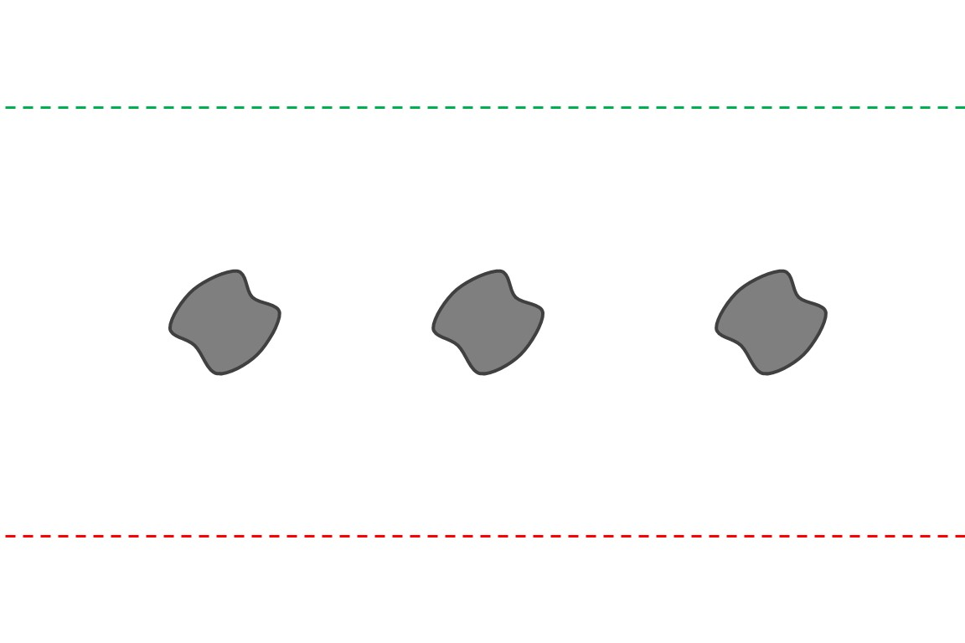
OVERVIEW Often, opposing Fleets will encounter one another whilst combing the wreckage of past battles or lost convoys in search of important data or valuable resources.
TERRAIN This Scenario has no special Terrain requirements. Simply set up the Game Board using one of the methods described on Page 35.
DEPLOYMENT This Scenario follows the normal rules for choosing your Deployment Zone and placing your Forces. The shapes of the Deployment Zones are shown on the Scenario Map.
SCENARIO RULES Replace the standard Debris Field Table with this alternative table:
Debris Field
1 Unexploded Munitions One model in the Squadron (chosen by the controlling player) immediately becomes the target of an attack with 1D6 + 2 Attack Dice
2 Radiation Leak One model in the Squadron (chosen by the controlling player) immediately loses 1D3 Crew Points
3, 4 Nothing No Effect
5, 6 Objective Recovered; Gain 250 Victory Points. This is now a standard Debris Field.
In addition, when any squad that is Destroyed or Shunted Out place a Debris Field in its place. A Tier 3 leaves 3” Debris Field, Tier 2 is a 6” Debris Field, and Tier 1 is an 8” Debris Field. These Debris Fields will be placed with the center located where the last Model was located, and are worth 250 VP each:
After a resource is recovered from a debris field a marker must be placed there to represent a resource has been recovered.
VICTORY CONDITIONS This Scenario has no additional Victory Conditions. Simply compare Battle Logs at the end of the game to determine the Margin of Victory (see Page 82).
GAME LENGTH During the End Phase of Turn 6, the Commander first in the order of Initiative should roll a D6. On a result of 1, 2 or 3 the game ends. On a roll of 4, 5 or 6 another Turn is played. Roll again during the End Phase of Turn 7, but subtract 1 from the result. If an 8th Turn is played, roll again but subtract 2 from the result. The game automatically ends during the End Phase of Turn 9.

