NOVA OPEN 2016

Firestorm Armada Narrative Event

Tournament Format
Maximum Fleet Value: 1200pts
When: Sunday, September 4th
Time: 9am-6pm
The Storm Zone has been a very volatile place for the past few years as neither side is willing to give ground. Recently both side have established listening stations to detect fleet movements in the sector. Both sides are planning a major offensive to capture and destroy the listening stations. Will your station survive the onslaught? Only the best commanders will prevail.
Rules: All the standard rules from version 2.0 Rulebook, plus all current FAQs/Errata. Optional Rules will be used for this Tournament. All Rules and FAQ’s/Errata will be locked as of August 1st.
Models: Fleets will be comprised of the current factions listed in the Fleet Manuals. Fleets will consist of ship Models currently available from Spartan Games. If a Model is not currently made by Spartan, then a suitable Proxy Model may be used. Proxy Models must be similar in size for ships of the appropriate Class. They must also use the same sized base as Models currently available from Spartan.

Models Cannot Touch Rule: Due to the rule on Page 51...
A model cannot end its Movement with its Flight Stand on top of another model's Flight Stand, or with any part of the model touching another model.
The following implied rules will be followed:
- Models cannot be removed from Flight Stands
- Models cannot be rotated on the Flight Stand
- Peg heights cannot be adjusted
Flight Stands: All players will use the supplied Flight Stand which came with their Model, with the following exceptions:
- Hawk Widgets: These may be applied to either end of the Flight Peg
- Corsec Omni-stand Flight Pegs: Only 2” pegs will be permitted
- Version 1 Models: These came with the normal flight stand, but if a Player wishes may instead use a Large Flight Stand
- Uneven Models: The Dindrenzi Praetorian (and other models) require modification to sit on the Flight Stand. One Flight Peg must be unmodified.
Gaming Supplies: Players are expected to bring all of the required Gaming Supplies for a game of Firestorm Armada:
- Firestorm Armada Turning Template
- 48”+ Tape Measure
- Enough Dice for their Fleet
- Firestorm Armada Markers (bring enough for your Fleet, including Hidden Set-up)
Scenarios: There will be 2 Rounds and players will have a 4 hour time limit to complete each Scenario. Players must make every attempt to complete to Turn 4. If Turn 4 is not completed in 4 hours, then the Tournament Organizers will either 1) allow the players to finish the Turn, or 2) make a judgement on the likely outcome for the rest of the game based on current positioning. The option chosen will be based on time constraints and conditions within NOVA. Tournament Points will be awarded accordingly.
Fleet List: Fleet lists must be submitted electronically by August 1st. Players must have a copy of their Fleet List with the Nova Stamp of Approval available for review by your opponent and judges at any time during the GT. Each player will be allowed two list.
Rulebook: All players must have a copy of the current Rulebook and FAQs available at all time during the GT. This can be a Digital copy but must be available for judges to view if asked. If your battery has died, you will have 10 minutes to recharge and demonstrate you have the digital copy.
Tournament Rounds and Rotation
At the beginning of the Narrative, players will be split up into two sides: Kurak Alliance and Zenian League. Each side will choose a player to be the commanding Admiral for the Narrative. Any Mauraders will first be selected by the Admirals. The Admirals for each side will then choose the pairings for the Round and the table. Players then will roll off to see who is Attacker and Defender. Players may start as soon as they are paired up and placed at a table.
If there is an odd number of participants at any time, one of the Tournament Organizers will play the Odd-Man Out. Narrative Scoring will not be adjusted; there is no ‘bye’. In addition, Tournament Organizers will not play someone they have played before, either at the Tournament or otherwise. Fleet list for the Tournament organizers will also have a Nova Stamp of Approval and be available any time for the Players to view.
While playing the Odd-Man Out, the Tournament Organizer will not perform any other Tournament Organizer duties.
Table Layout
Each Round will be held on a 4’x6’ Table, with Terrain already placed. Players may move the Terrain Templates, and adjusting the decorative 3D Terrain Models is allowed. If there are any questions as to which Mission to play on any given Round, please ask a Tournament Organizer.
Narrative Scoring
Scoring will be done for each side using the average battle log for each side. All players will be added up and then averaged to give each side their score. The losing Admiral from the first Round will make the first pairing in the second Round.

Scenario 1: Defend the Listening Station
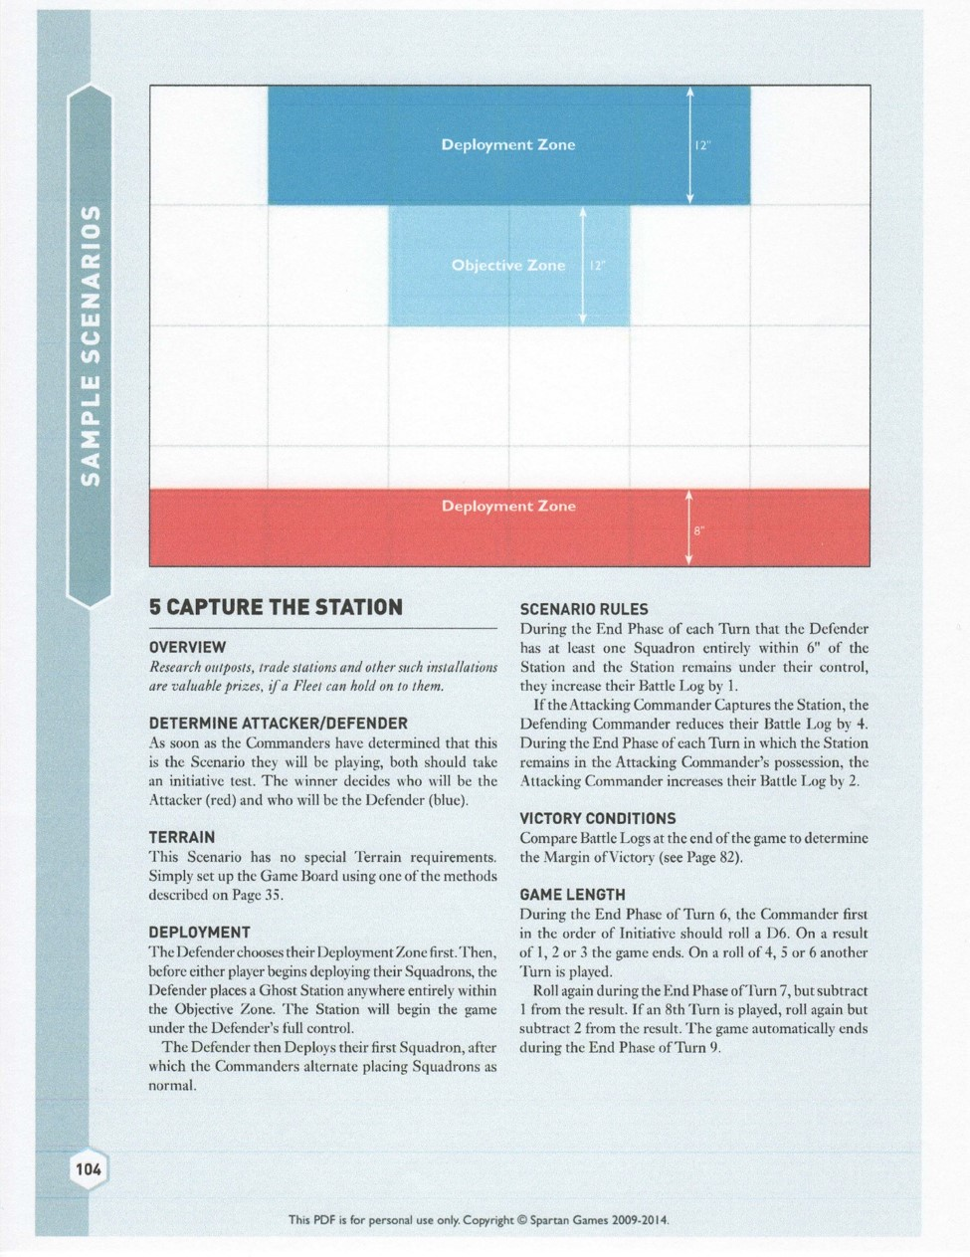

Mission 2: Ambush, Reinforcements Inbound
